GAVDNet Adjudicator V1.0

User Manual

# Overview

The GAVDNet Adjudicator is a standalone MATLAB application for validating disagreements between the detections returned by the automated call detector GAVDNet, and ground truth annotations. It is to be used in cases where the ground truth dataset annotations used to benchmark the detector are unreliable.

The adjudicator’s task is to inspect spectrograms for the audio that the detector and ground truth disagree on and decide whether the spectrogram shows the whale song of interest.

# Installation

1. Run the “AdjudicatorInstaller_mcr.exe” file. This should install both MATLAB Runtime, and the Adjudicator app.
2. If this does not work, download MATLAB Runtime from the link below and install it, then try launching the Adjudicator app again.

<https://au.mathworks.com/products/compiler/matlab-runtime.html>

1. If this still doesn’t work, contact [b.jancovich@unsw.edu.au](mailto:b.jancovich@unsw.edu.au)
2. Make sure that the “TestSubset” folder is in the same directory as the “disagreements” file and the “GAVDNetAdjudicator.exe” file.

# Main Display

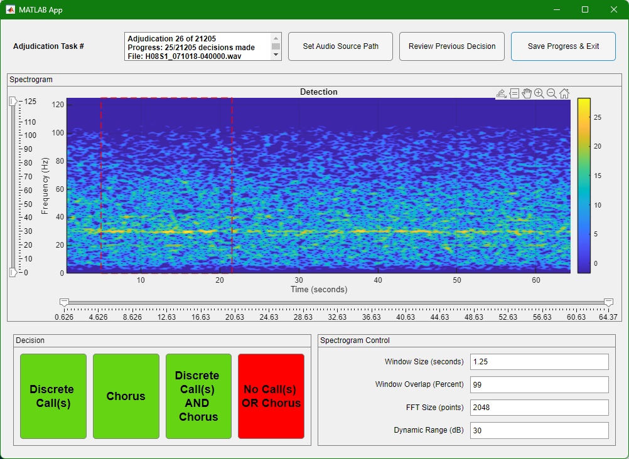

Adjudication Task Display Panel

* Current Task: e.g. Task 1 of 10
* Progress Counter: Displays how many decisions have been completed
* File Name: The name of the audio file being reviewed

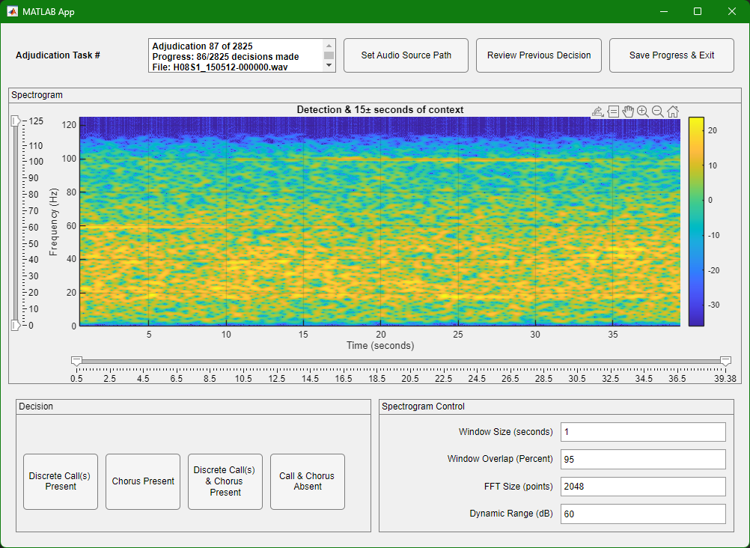

## Navigation Controls

* Set Audio Source Path: reset the path to the audio. If you set the path correctly at the beginning of the session, you shouldn’t need this.
* Review Previous Decision: Go back to the previous disagreement to review or change your decision
* Save Progress & Exit: Save your work and close the application. Decisions are saved in the disagreements .mat file.



## Spectrogram Display Panel

The maindisplay shows a spectrogram of the audio in the time region of the detected call, beginning 5 seconds before the actual detection, to give some context. The end of the spectrogram is either 40 seconds from the detection start time, or the end of the detection, whichever is longer. The colour scale represents power in decibels.

A red dashed-line box indicates the time bounds of the current detection, according to the detector. Note that due to chorus or multiple discrete songs occurring in quick succession, there may be song or chorus visible outside this box. If this is the case, this may help to inform decisions, but ultimately, it is the time region within the red box that you are making decisions on.

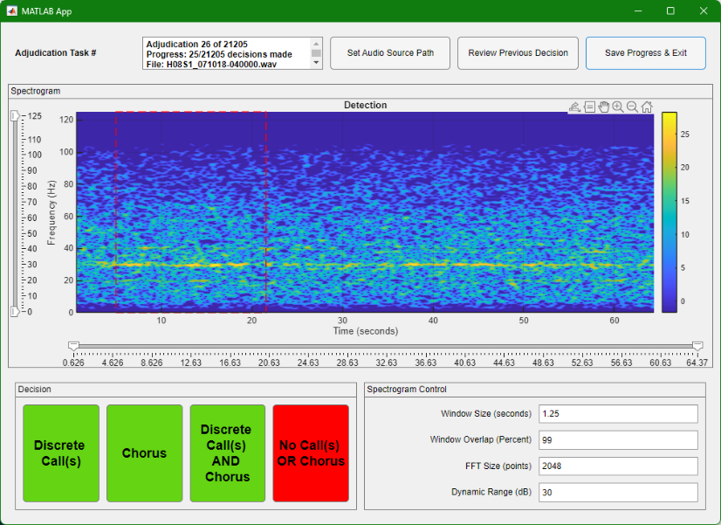

## Spectrogram Control Panel

Adjust these settings to better visualize the data:

* Window Size (seconds): Length of analysis window (default: 1s)
* Window Overlap (percent of window): Overlap between windows (default: 95%)
* FFT Size (points): Frequency resolution (default: 2048)
* Dynamic Range (dB): Colour scale range (default: 30 dB)



## Spectrogram Zoom Controls

Zoom on the time and frequency axes of the spectrogram display are controlled via the slider handles. Sliding the max and min sliders will adjust zoom and the visible range. The range of colours in the spectrogram automatically adjust based on the frequency axis zoom. When you zoom in on a specific frequency range using the vertical slider, the colour scale recalculates to use only the spectrogram data within the frequency range being displayed. This means the brightest colours (yellow) will always represent the highest power levels *currently visible* on the display. This ensures that the dynamic range control is correctly applied, displaying the relevant region of the spectrogram with maximum contrast. Without this automatic colour scaling, subtle shapes in the spectrogram are easily washed out by higher-power regions outside the frequency range we are interested in.

# Getting Started

## Launching the Application

* 1. Run Adjudicator.exe
  2. The app will open a file selection dialogue box, asking you to load the disagreements file. This will have a file name like “detector_vs_GT_disagreements_30-May-2025_07-38-49.mat”.
  3. The app will open a folder selection dialogue box, asking you to show it the folder where the test audio is. This folder will have a name like “TestSubset”.

## Set up the Spectrogram

Once the first spectrogram displays, set up the spectrogram display. The default spectrogram window size, overlap and FFT length should be appropriate for most baleen whale songs. You will likely play with the dynamic range setting to better visualise detections with varying SNRs. Zoom the frequency range in to show the bandwidth of interest, something a little wider than the range occupied by the target call. For example, for an Antarctic Blue Z call, which contains energy in the 30 - 15 Hz range, recommended frequency zoom settings are 5 to 50. Setting the range a little wider than the call’s actual bandwidth allows easier discrimination between chorus and broadband noise. Note that the zoom settings are persistent within a session, but will reset when you close and re-launch the app.

## Data Management

* Save progress regularly using **"Save Progress & Exit"**
* The app automatically tracks your position and resumes where you left off
* All decisions are saved to the original “disagreements” data file
* Upon completion of the adjudication, please return this “disagreements” file.

## Making Decisions

Inspect the spectrogram, experimenting with dynamic range to reveal low SNR calls. Remember that the call could be anywhere in the time region displayed. Refer to the “Adjudication Reference” file, which contains spectrograms that illustrate the call of interest. Choose the option that best describes what you observe in the spectrogram:

|  |  |
| --- | --- |
| Decision Button | When To Use: |
| Discrete Call(s) Present | Individual whale calls (or parts thereof) are visible. |
| Chorus Present | Multiple, overlapping calls/reverberation/multipath reflections creating an indistinct horizontal band of energy that has the same frequency bandwidth as the call of interest. May resembles narrow band noise, or a continuous tone at the same frequency as the song of interest. |
| Discrete Call(s) & Chorus Present | Both discrete calls (or parts of calls) AND chorus are visible. |
| Calls & Chorus Absent | No features resembling discrete calls, parts of calls, or chorus are visible. The spectrogram shows only noise, other extraneous (non-target) sounds, or silence. |

When attempting to identify whether spectrograms contain chorus, remember that the frequencies of baleen whale songs are shifting downwards over a decadal time scale. For a table of frequencies in different years, see the Frequency Shift section below.

Remember to use the **"Review Previous Decision"** button if you think you have made an error.

## Dynamic Range

The dynamic range setting is useful to suppress noise or make low power sounds in the spectrogram stand out with more contrast. Due to the automatic scaling of colour limits in the spectrograms however, the dynamic range setting that is best for one task may not be the best for another. Below is an example.

This spectrogram has a high-power region at the low frequencies, around the 50 second mark. The dynamic range setting is 20dB, too small to accommodate the full range of magnitude values. As a result, most of the spectrogram is compressed to a value of zero and appears artificially as silence.

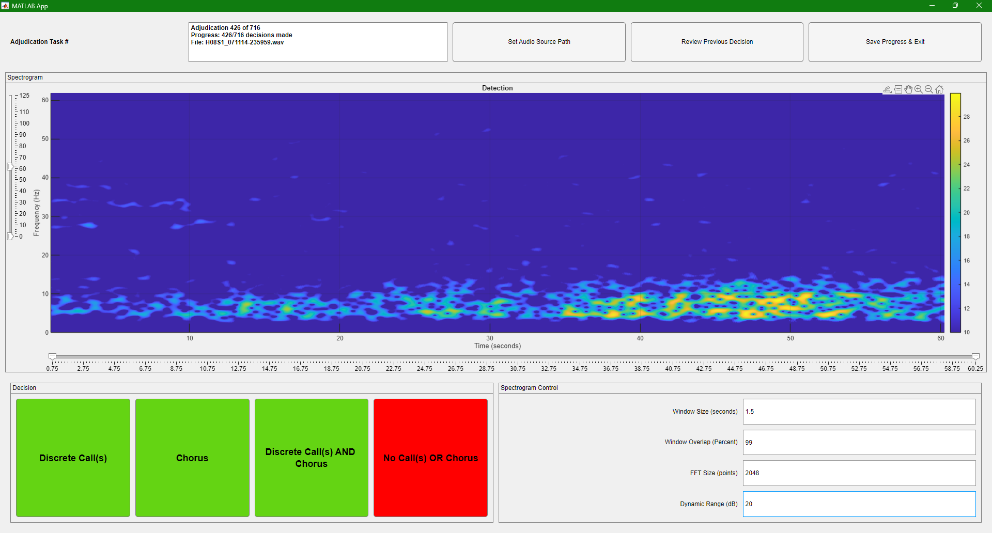

Increasing the dynamic range to 40 dB reveals low magnitude details that were hidden. This brings up the noise floor, but also makes the very low SNR song at the very start of the spectrogram easier to spot:

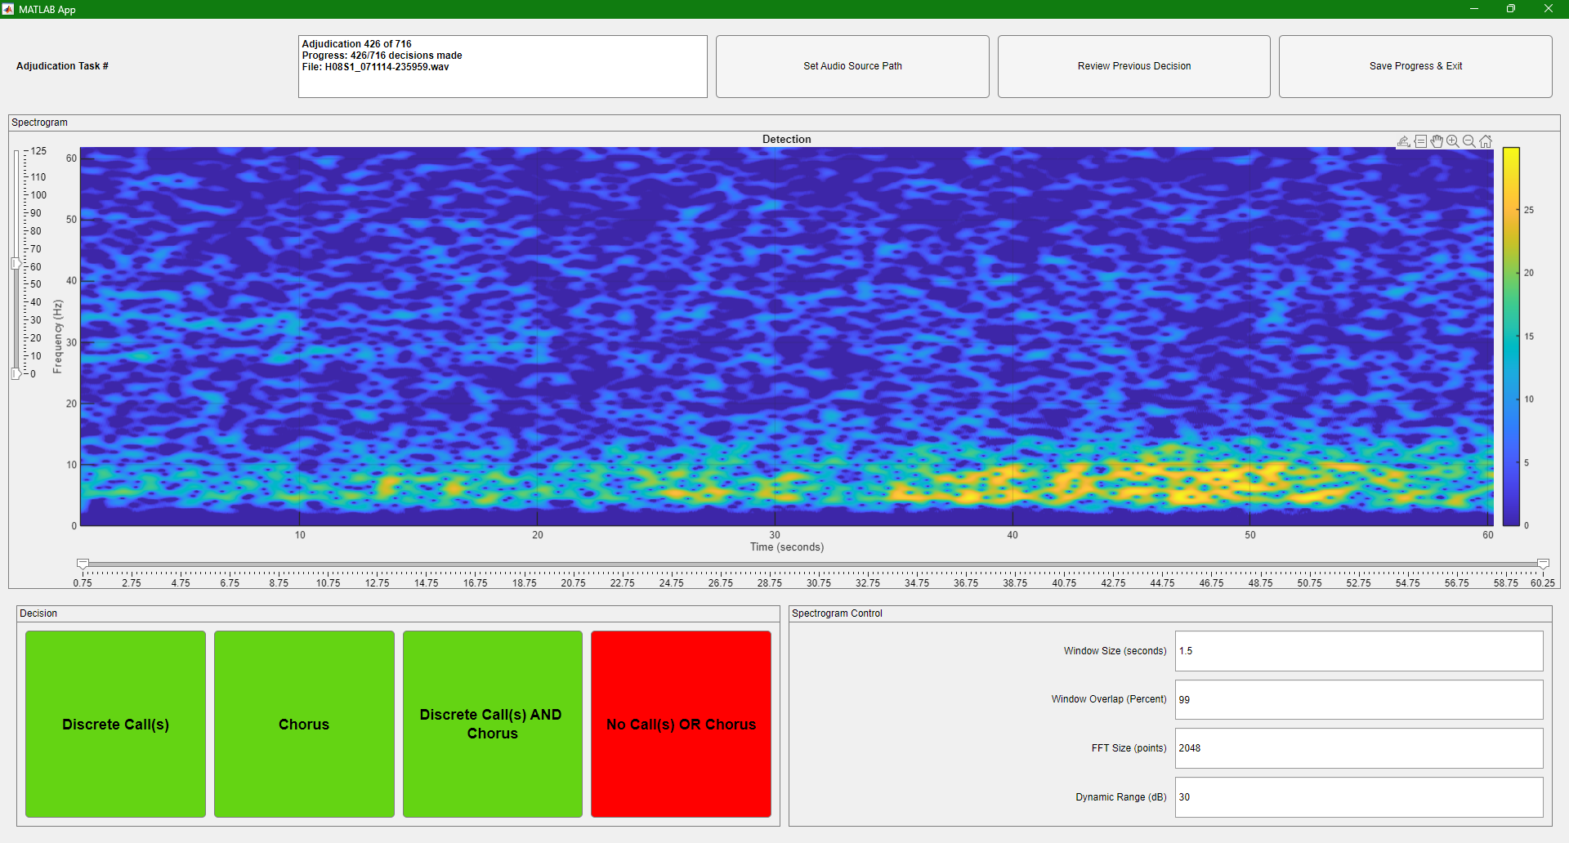



## Chorus Examples

Below is a spectrogram of the 2017 Chagos pygmy blue whale song reproduced from (Leroy et al., 2021), computed with a window duration of ~4 seconds with 90% overlap.

Figure : Spectrogram of the Chagos pygmy blue whale song. Image reproduced from Leroy et al., (2021) “Multiple Pygmy Blue Whale Acoustic Populations in the Indian Ocean.”

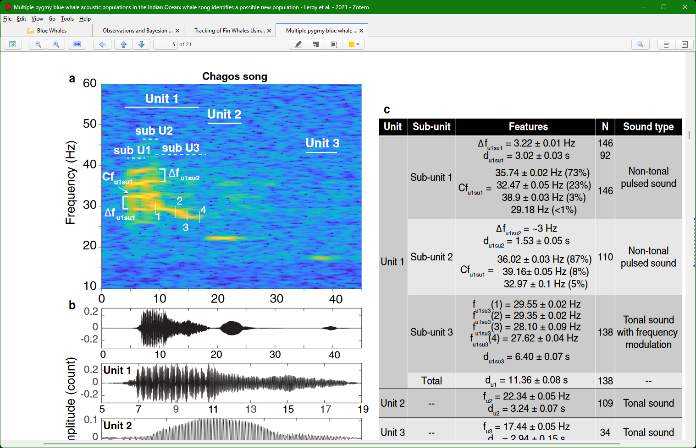Note that the song has discrete tones occurring at approximately 45Hz, 42.5Hz, 37-38Hz, 35-36Hz, 33Hz, 28Hz, 26Hz, 22Hz and 16 Hz.

The spectrograms below were all computed with a window duration of 1.25 seconds and an overlap of 99%. These spectrograms all show a chorus of the Chagos song, identifiable by the horizontal bands of energy whose frequencies correspond approximately to the frequencies of the discrete tones. The energy bands need not be continuous to qualify as chorus. If there is tonal energy at a song frequency that persists for longer than the corresponding tone lasts in the discrete song, this qualifies as chorus.

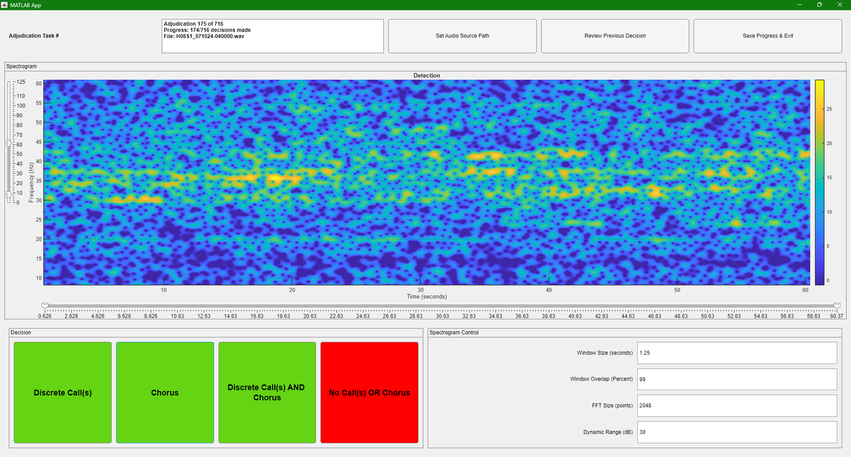

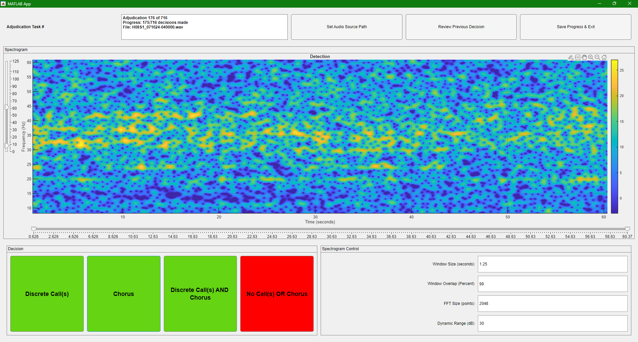

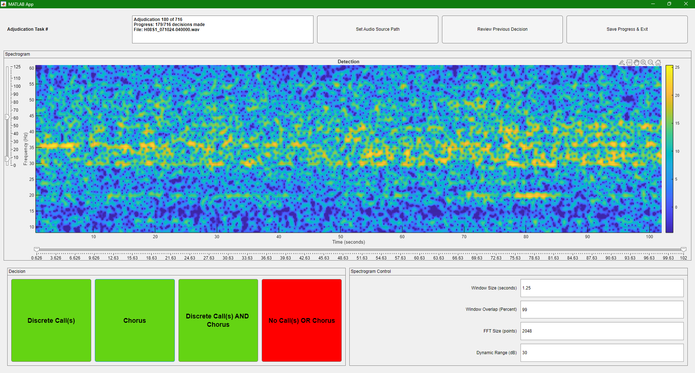

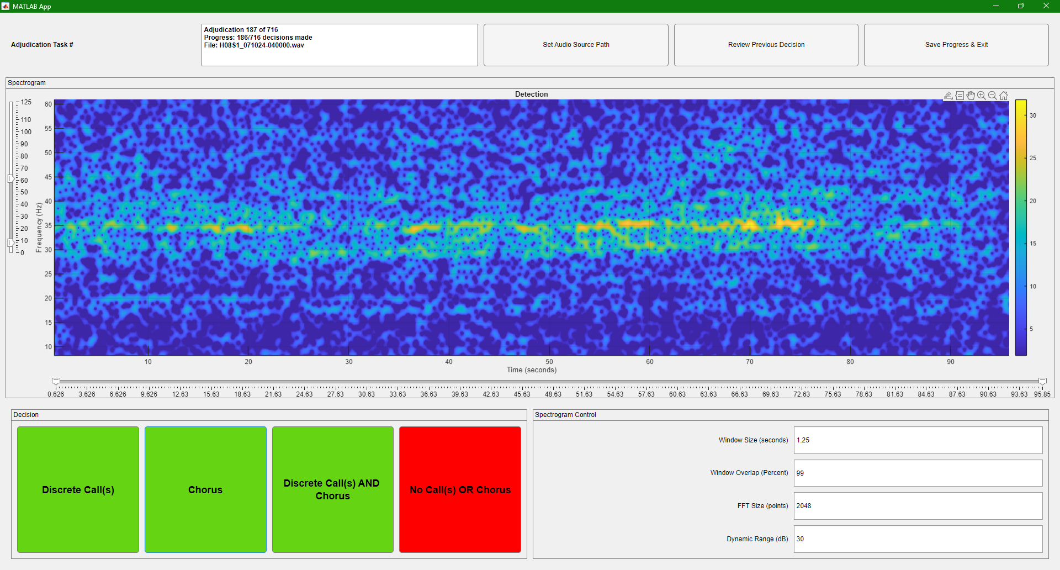

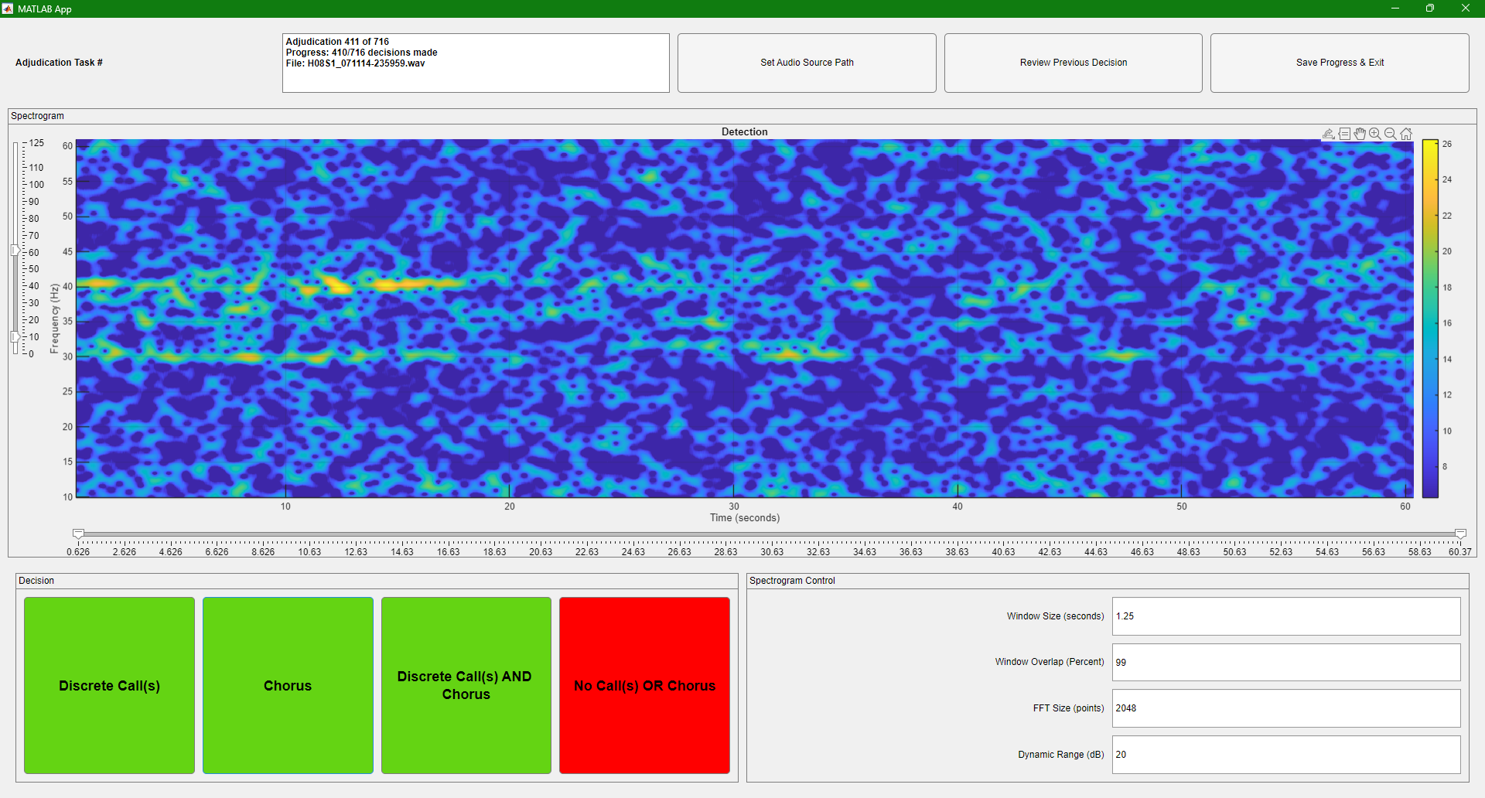

## Frequency Shift

The following table gives approximate centre frequencies for tonal components in the Chagos song and the Antarctic Bue Whale’s Z-Call. The values in this table are approximate and are based on descriptions of frequency shift in (Leroy et al., 2021) and (McDonald et al., 2009).

|  |  |  |
| --- | --- | --- |
| Year | Chagos pygmy Blue Whale  Middle tone in  Unit 1, Subunit 1 | Antarctic blue whale  Z-Call  Middle of Unit-A |
| 2000 | 38.58 | 27.825 |
| 2001 | 38.25 | 27.69 |
| 2002 | 37.92 | 27.555 |
| 2003 | 37.59 | 27.42 |
| 2004 | 37.26 | 27.285 |
| 2005 | 36.93 | 27.15 |
| 2006 | 36.6 | 27.015 |
| 2007 | 36.27 | 26.88 |
| 2008 | 35.94 | 26.745 |
| 2009 | 35.61 | 26.61 |
| 2010 | 35.28 | 26.475 |
| 2011 | 34.95 | 26.34 |
| 2012 | 34.62 | 26.205 |
| 2013 | 34.29 | 26.07 |
| 2014 | 33.96 | 25.935 |
| 2015 | 33.63 | 25.8 |
| 2016 | 33.3 | 25.665 |
| 2017 | 32.97 | 25.53 |
| 2018 | 32.64 | 25.395 |
| 2019 | 32.31 | 25.26 |
| 2020 | 31.98 | 25.125 |
| 2021 | 31.65 | 24.99 |
| 2022 | 31.32 | 24.855 |
| 2023 | 30.99 | 24.72 |
| 2024 | 30.66 | 24.585 |
| 2025 | 30.33 | 24.45 |

## References

Leroy, E. C., Royer, J.-Y., Alling, A., Maslen, B., & Rogers, T. L. (2021). Multiple pygmy blue whale acoustic populations in the Indian Ocean: Whale song identifies a possible new population. *Scientific Reports*, *11*(1), 8762. https://doi.org/10.1038/s41598-021-88062-5

McDonald, M. A., Hildebrand, J., & Mesnick, S. (2009). Worldwide decline in tonal frequencies of blue whale songs. *Endangered Species Research*, *9*, 13–21. https://doi.org/10.3354/esr00217